Tuesday April 15, 2025
6:30PM

Location
- Please see below a draft of the principal update. While some topics will be discussed during the meeting (noted below), as we seek to be cognisant of time, I have provided a brief outline below. That being said, there will always be opportunity for questions.

Principals’ Report

- 2025 - 2026 Updates
  - RAM
  - Beginning conversations will be shared at the meeting

- School Engage
Results from parent/guardian survey (161 responses)
    - We share School Development Plan information and updates in different ways. Please indicate the ways you have learned about our SDP. Check all that apply:
      - School website (54%)
      - School Council Meeting (14%)
      - SchoolMessenger (61%)
      - Other (14%)
    - My Child’s Learning can benefit from the goals, outcomes, actions and resources in the School Development Plan:
      - Strongly agree (35.7%)
      - Agree (55.3%)
      - Disagree (7%)
      - Strongly disagree (1%)
    - The learning of all students is reflected and prioritized in the goals, outcomes, actions and resources in the SDP:
      - Strongly agree (30.3%)
      - Agree (50%)
      - Disagree (17.8%)
      - Strongly disagree (1%)
    - The activities our school provides (e.g. field trips, guest speakers, experts in schools, sporting activities, outdoor education, etc.)are important to my child’s learning:
      - Strongly agree (35%)
      - Agree (63%)
      - Disagree (2%)
      - Strongly disagree (0%)
    - The school fees I pay are reasonable considering the benefit they provide my child:
      - Strongly agree (26%)
      - Agree (63%)
      - Disagree (9%)
      - Strongly disagree (1%)

Schools must operate within their budget and too many fees can be unmanageable for families. Knowing that, please rank the following activities and services in order of importance to you.

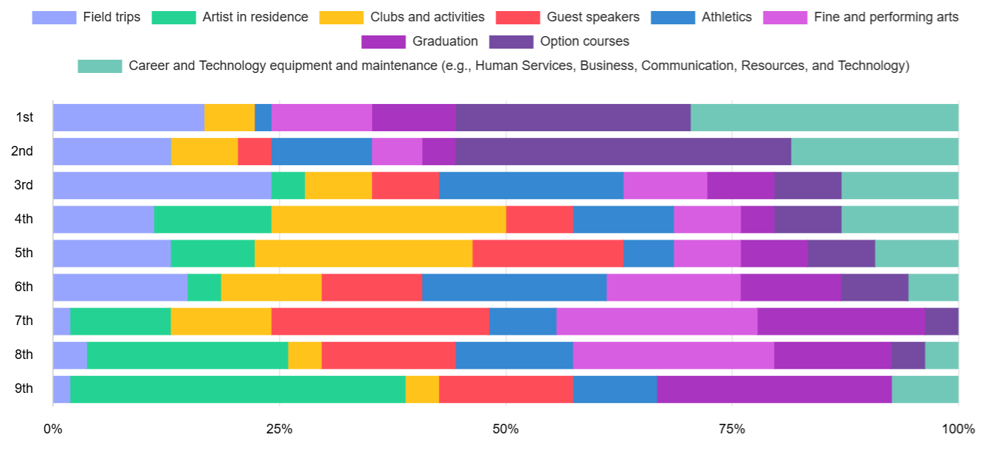

- Athletics Updates
  - Spring Sports (boys rugby, girls rugby, junior boys soccer, senior boys soccer, field hockey and track and field).

- Fine and Performing Arts Updates
  - Juvie Tuesday – Thursday this week. Doors open at 6:30 for show at 7:00. The show has a cast of 17, and is technology supported by the Tech 15 class. It is a one-act play where students get to delve into character work and into the raw emotions of teens in Juvenile Detention.
- Other School Updates
  - Our school has the opportunity to participate in Student Vote this year. As Canada heads to the polls on April 28th, so will we! Each student will be able to participate in a mock-election which allows them to experience the excitement of the democratic process firsthand and have a say in who they want to represent us in Ottawa. Since we are located in Calgary - Crowfoot we stage our election using that ballot.
  - Just after spring break, we had a field trip to Bamfield – a joint trip with Winston Churchill High School
  - This past week, our Holistic Wellness Learning leader took a small group of student to ‘Seeds of Connection’ – Anti Racism Program
  - At the end of the month, our Outdoor Education class heads to the Canadian Rockies Outdoor Learning Centre for a few days
  - Near the end of May, once again, we will be supporting a field experience to the Yukon

