cbe.ab.ca/b880

Robert Thirsk High School
2024-2025 Complementary Registration Guide

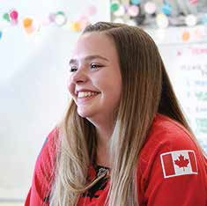
personalizing

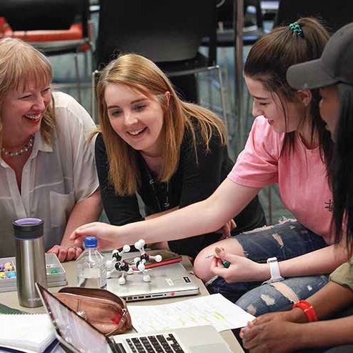
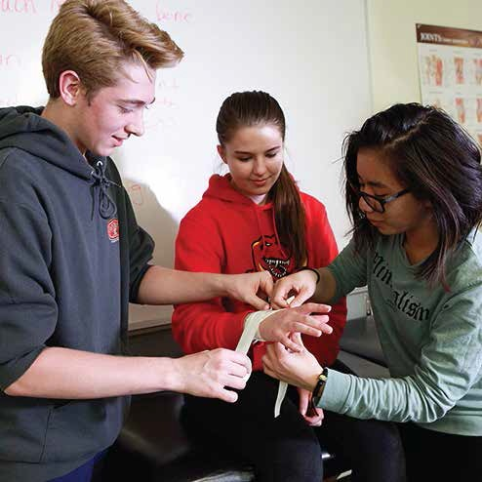
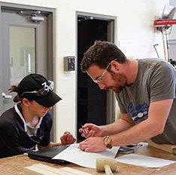

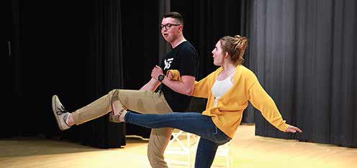
thriving

connecting





Table of Contents
Complementary Courses 3
Creative Writing & Publishing 3
Journalism …………………………………………………………………………………3
Forensic Science ……………………………………………………………………… 3
Mathematics15…………………………………………………………………………….3
Psychology 3
Yoga 3
Global Studies…………………………………………………………………………… 4-5
Aboriginal Studies 4
English Language Learning (ELL) 4
International Students 4
French as a Second Language 5
Spanish Language and Culture 5
Fine Arts Programs 5-8
Art 6
Music 6
Drama 6
Musical Theater 7
Dance 8
Technical Theatre 8
Film and Media Art………………………………………………………………………..8
Career & Technology Studies (CTS) Registration Guide 8-12
STEM (Robotics, Computer Science & Design studnies)…………………………….8
Business Administration, Finance and Information Technology (BIT) 10
Health, Recreation & Human Services (HRH) 10
Media, Design & Communication Arts (MDC) 11
Natural Resources (NAT) 11
Trades, Manufacturing & Transportation (TMT) ………………………………… 12
Work Experience, RAP and Green Certificate 12
Advanced Placement (AP), Dual-Credit, & Other Unique Courses 13-16
STEM AP Courses………………………………………………………………………14
Humanities & the Arts AP Cohort……………………………………………………...15
RTHS Course Listings 17


Complementary Courses
Note| All complementary courses at RTHS will be offered based on student interest, enrolment and school resources.

Creative Writing & Publishing 15/25/35
Students will create their own texts, and follow those texts through the editing, publishing and marketing processes. Students will also explore the processes and conventions of publishing and marketing creative writing. Prerequisite: CW 15 or 25

Journalism 15/25/35
The Journalism courses provide students with the opportunity to explore, create, and reflect through journalistic media. In this course students evaluate the impact, responsibility and ethics of media in society, develop skills in creating texts for diverse audiences, and collaborate to contribute and problem solve in the context of creating media texts, and learn by setting goals and reflecting throughout the production process. Prerequisite: Journalism 15 or 25

Forensic Science 25/35
Students will explore the use of basic forensic concepts and technologies to solve crimes. Concepts may include the collection and analysis of evidence from crime scenes and the principles of fingerprinting, breathalyzers, polygraphing, and DNA analysis. A major component of the course is the analysis of real crimes and crime scenes. Prerequisite: Science 10 or 14

Mathematics 15
Math 15 is for students looking to improve their mastery of foundational mathematical skills, concepts and ideas. This course will help students extend knowledge beyond performing routine operations, explore a deeper understanding of mathematical concepts through critical thinking and exploration exercises. Students will bridge their mathematical skills and better prepare students for math 10C. Prerequisite: Jr. High teacher recommendation

Psychology
Students explore views on scientific principles within the field of psychology through. Students can enroll in Positive Psychology 15 in grade 10, then continue in psychology 20 and 30. Students will receive, practical, scientific, and theoretical knowledge in the field of psychology. At the 20 and 30 level the course is divided into 2 3 credit courses. Prerequisite: None

Yoga 15/25/35
Students will progressively learn a variety of Asanas (postures), breathing techniques, and meditations. As students advance in the program, they will study alignment, anatomy and learn to build complimentary sequences. Students in all levels of yoga will relieve stress, and explore how balance and yoga contribute to their sense of wellbeing. Prerequisite: Yoga 15 or 25

Global Studies
Learn how to connect and lead in a global society through opportunities including: partnerships, exchange opportunities, 1 to 2 day intensive language learning events, participation in an international youth summit, international travel opportunities and/or completion of an international certificate (https://sites.google.com/a/educbe.ca/global-learning/products-services).

Aboriginal Studies 10/20/30
Students will build an understanding of diverse Aboriginal cultures within Alberta, Canada, and the world. As students progress in their understanding, they will reflect on the connections and changes made to the Aboriginal cultures by government policies, treaties, and the residential school system. Students will explore what Truth and Reconciliation means in Canada today. Prerequisite: None

English Language Learning
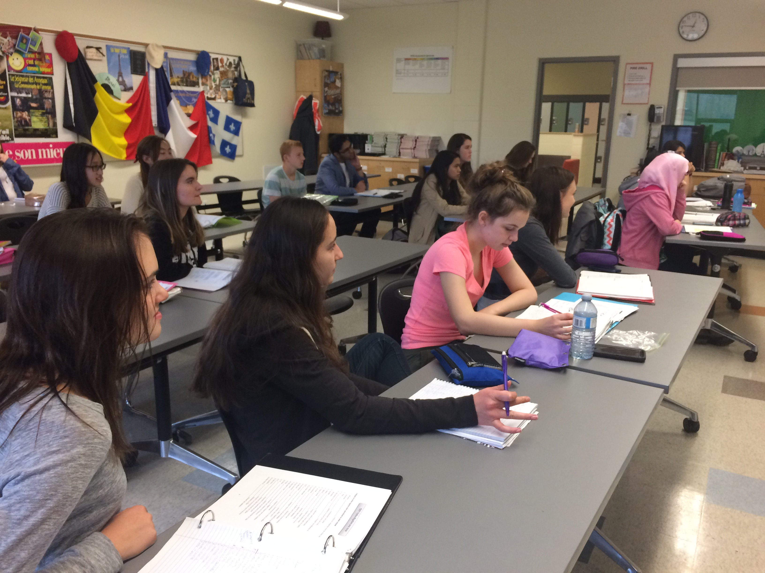
ELL students may be required to complete an English Language assessment upon arrival in order to determine their language proficiency level and ELL class placement. The focus of all levels is to develop English communication skills including reading, writing, listening and speaking. Students will also explore Canadian culture and academics. Advancing to the next level is dependent upon the student mastering the language requirements.

International Students
International students are welcomed to Robert Thirsk High School to pursue their high school academic requirements and/or to improve their English Language proficiency. International students can expect high quality education with opportunities to participate in clubs and athletics. International students will have the opportunity to participate in a variety of experiential trips to learn about the natural beauty and history of southern Alberta and the Rocky Mountains. For more information, please visit the following link: http://cbeinternational.ca/

Second Language

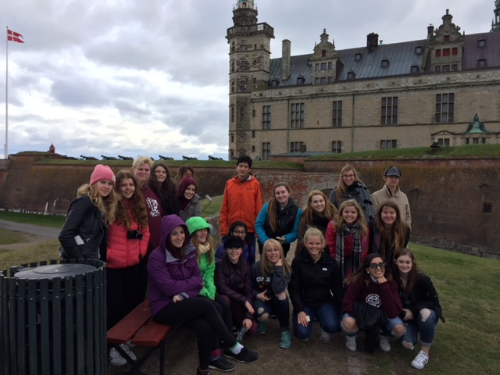
French as a Second Language

French 10
An introductory course designed to provide a practical learning experience using a theme-based approach, no previous French required. Prerequisite: None

French 20
Students who have successfully completed up to and including grade 9 French are recommended for the French 20 Level. Prerequisite: Grade 9 French or French 10

French 30
Students who have successfully completed an immersion program should register for the French 30 Level, or discuss a Course Challenge with the teacher, which are twice a year centrally through the CBE. Prerequisite: French 20

Spanish Language and Culture

Spanish 10
An introductory course designed to equip students with a practical knowledge of Spanish, no previous Spanish is required. Prerequisite: None

Spanish 20
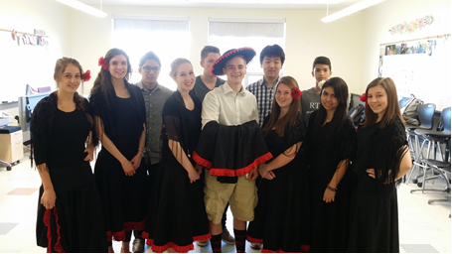
Students will produce and interpret oral texts using a combination of sentences and increasing language independence. In Spanish 20 students will begin to express preferences and describe personal experiences with emotions. Also, students in this class will begin to express their own opinions and recognize differences of opinion. Prerequisite: Spanish 10

Spanish 30
Spanish 30 students will increase their language independence by improving their ability to manage short interactions appropriately. Students will begin to use Spanish more creatively, to solve problems, and to interpret and respond to a variety of emotions. Prerequisite: Spanish 20

Spanish L&C 30AP
AP Spanish Language and Culture is equivalent to an intermediate level post-secondary course in Spanish. Students acquire understanding of the Spanish language through speaking, listening, writing and reading. The AP Spanish Language and Culture course strives not to overemphasize grammatical accuracy at the expense of communication. Students will explore concepts such as family and community, personal and public identities, contemporary life and global challenges. This course is taught almost exclusively in Spanish. Students who wish to take this course must have completed and excelled at Spanish Language and Culture 20, or completed Spanish Language Arts 10. Prerequisite: Spanish Language Arts 10 or Spanish 20/30 with teacher recommendation

Fine & Performing Arts Programs
Enhance your experience in high school by adding Fine Arts courses and accessing our Fine Arts spaces. Committed students will have the opportunity to complete the CBE Fine and Performing Arts Certificate https://cbe.ab.ca/programs/program-options/Documents/Fine-Performing-Arts-Certificate.pdf

Art

Art 10
Students develop new skills and refine previously acquired skills through the exploration of various materials and techniques. Opportunities to creatively express yourself through various methods of painting, drawing, and sculpting will be provided. Prerequisite: None
Art 20
Students will develop, expand and refine their abilities in communicating visually. They will be encouraged to experiment with materials and techniques while selecting personal themes for expression. Prerequisite: Art 10

Art 30
Students will develop independent and stylistic characteristics common to practicing artists. Personal experiences will be drawn upon as a source of inspiration for artistic creations. Students will research selected artists and periods to broaden their understanding and appreciation of Fine Art. Prerequisite: Art 20

Art 35 AP

The AP Art and Design program consists of three AP courses: 2-D Art and Design, 3-D Art and Design, and Drawing. Students create a portfolio consisting of 10-15 highly developed works of art that demonstrate students' abilities and showcase the inquiry process through art and design. The courses encourage students to show the experimentation and growth required to create a substantial and cohesive inquiry portfolio. The Exam requires students to submit 15 images of their Sustained Investigation and mail 5 pieces of refined work to The College Board for review in May.

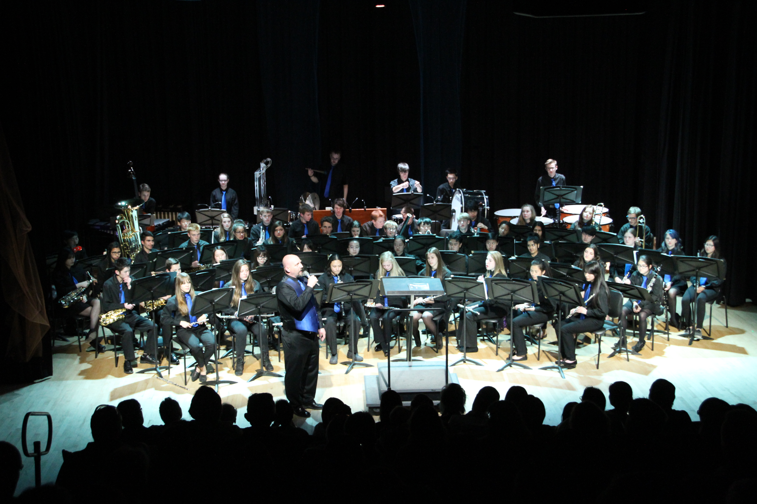
Music
Instrumental Music 10/20/30
Students will have the opportunity to play a wind (brass or woodwind) or percussion instrument, and will develop tone, range and flexibility. Students will perform music from a variety of periods and styles, and explore the theoretical and historical concepts as they pertain to the music. All students are expected to be involved in the performance- based aspects of the course. Prerequisite: Grade 9 Band or equivalent experience, Instrumental Music 10 or 20.

*The following “performance-based” band courses meet outside of regular class time, and do not affect course choices within the regular timetable. The performing groups include Concert band and Jazz band.

*Concert Band 15/25/35
Co-requisite: Instrumental Music 10, 20 or 30
*Instrumental Jazz 15/25/35
Co-requisite: Instrumental Music 10, 20 or 30

General Music 10/20/30
Students will explore many aspects of the music business, while learning and writing songs, learning the basics of multi-track recording, and learning some basic music theory. General Music is for students interested in music recording, production and engineering or students who play an instrument (guitar, drums, bass, etc.). Please note, you do not need to know how to play an instrument to be in this course, you just need to have an appreciation for music. Prerequisite: None

Drama
In addition the drama courses below RTHS puts on an annual drama production that all students may audition for. Students with a successful audition, who are cast in the production are eligible to receive advanced acting credits.

Drama 10
Students will work collaboratively and creatively with other students in a supportive and positive environment. The focus will be on orientation, mime, movement, improvisation, reader’s theatre, theatre history, storytelling, and technical theatre. Emphasis will be on participation, collaboration and the willingness to take risks. Prerequisite: None

Drama 20
Students will build upon the skills and experiences of Drama 10, while at the same time working through: orientation, collective creation, tech theatre/design, scripted mime, and acting to script, an introduction to playwriting, monologues and improvisation. Prerequisite: Drama 10

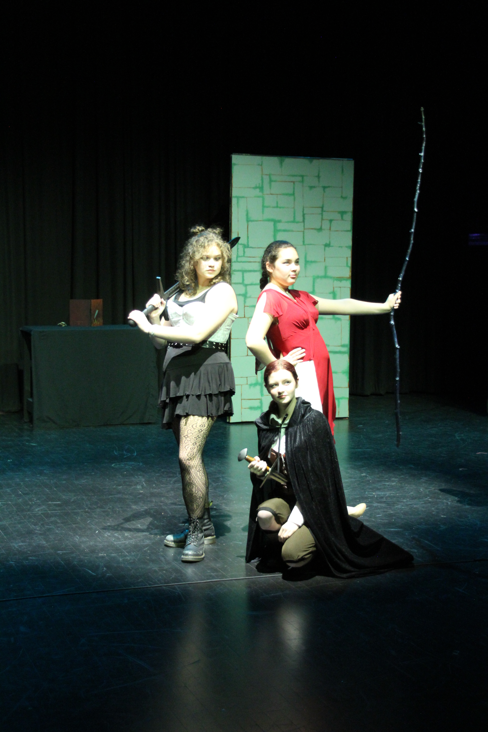
Drama 30
Students will continue to work in different disciplines with a focus on orientation, collective creation, dramaturge, improvisation, playwriting, the one act form, tech theatre & design, directing, acting to scripts and monologues for audition. Prerequisite: Drama 20

Musical Theatre
Musical Theatre 15
Students will explore acting, movement, and vocal skills through participation in a cast production involving teamwork, commitment and collaboration. The class will explore character development, creativity, and performance. The culmination of the semester’s work is the production of a full-scale musical. Prerequisite: Drama 10

Musical Theatre 25
Students will develop a deeper complexity and growth in character development, movement and vocal skills. Students will demonstrate leadership when rehearsing songs and scenes with other students, as well as taking responsibility in other artistic elements of the production. Prerequisite: Musical Theatre 15

Musical Theatre 35
Students will develop a higher level of complexity and growth in character development, movement and vocal skills. Students will take on strong leadership roles in the rehearsals and productions. Students will help conceptualize and realize artistic elements of the production. This course is required for most post- secondary Performance Programs. Prerequisite: Musical Theatre 25

Note| All levels of Musical Theatre will require performance participation; there will be after school rehearsals and mandatory evening commitments during show performance week.

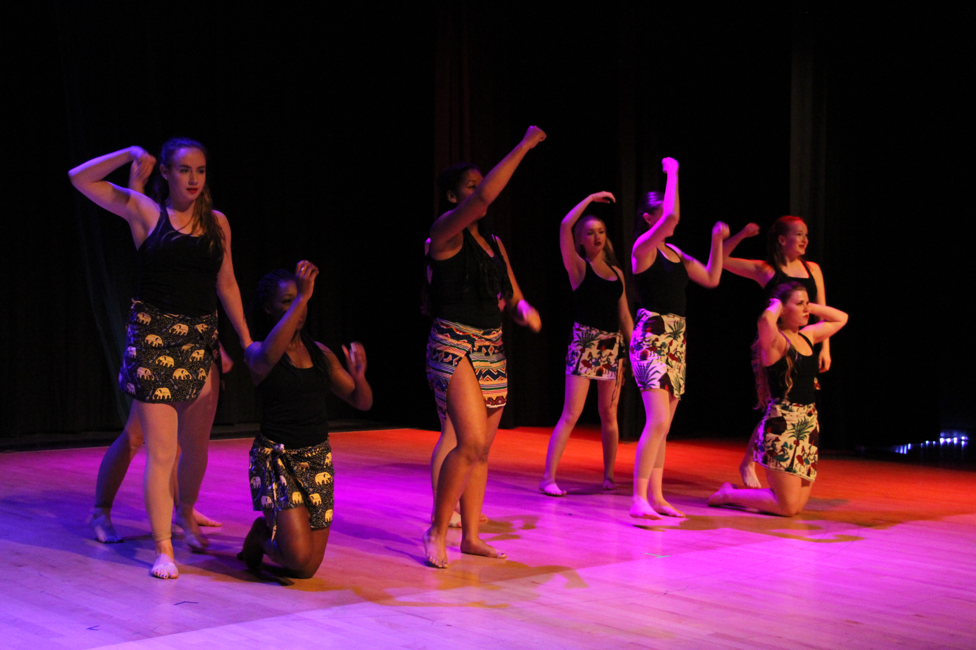
Dance
Dance 15
Students will be introduced to a variety of dance styles; including jazz, hip-hop, ballet, lyrical, creative, West African, funk, and modern dance. Technique, creativity, choreography, performance, safety, anatomy, history, and dance awareness are emphasized and assessed in this class. Prerequisite: None

Dance 25
Students will be challenged to build on their dance skills from Dance 15, and will develop leadership skills by collaborating and contributing to class warm ups and choreography. Prerequisite: Dance 15

Dance 35
Students will continue to build on the dance skills learned in Dance 25, with an emphasis on developing leadership skills and creating choreography.
Prerequisite: Dance 25.

*All dance classes have a performance element. Dances learned in class will be presented at school shows. Dancers will demonstrate all the elements of a rehearsed and polished performance.

Technical Theatre
Technical Theatre 15/25/35
Students will explore the non-acting components of theatre in a hands-on environment. Students will provide technical support for various events throughout the school year, such as the Remembrance Day Service, Dance Shows, Musical Theatre Shows, and Drama Productions. Required components of this course may occur outside of the timetable and in various areas of the school. Prerequisite: Technical Theatre 15 or 25.

Film and Media Art
Film and Media Art 15/25/35
Students will explore the technical side of filmmaking. In this course students will watch films to analyze and critique the artistic and technical elements. Students will also receive practical film making experience as student will also be able to create their own movies. After taking this class students will have a well-rounded understanding of Film as an artistic medium. Prerequisite: Technical Theatre 15 or 25.

Career & Technology Studies

CTS  Clusters | Business Administration, Finance & Information Technology | Health, Recreation & Human Services | Media, Design & Communication Arts | Natural  Resources | Trades, Manufacturing & Transportation | Multidisciplinary
 | BIT | HRH | MDC | NAT | TMT | MD
Occupational Areas | - Business Studies  - Computing Science (Pre-Engineering) | - Foods Culinary Arts  - Legal Studies  - Leadership  - Rec Leadership  - Sports Medicine  - Sports Performance | - Graphic Design | - Natural Resources  - Environmental and Outdoor Education | - Construction  - Robotics (Pre-Engineering) | - Design Studies
- Did you know that you have access to courses outside of Robert Thirsk High School?
- Be a student of Robert Thirsk High School and also take a course at the CT Centre. Opportunities are waiting for you! Career & Technology Centre: Students, you are invited to consider the unique hands-on opportunities available at the CT Centre. The CT Centre is located at the Lord Shaughnessy Campus, 2336 – 53 Avenue SW (403-777-7971).
- For additional opportunities to personalize your educational experience, please refer to the course offerings outlined in the Career & Technology Centre Course Guide at the CT Centre website: http://www.ct-centre.ca/ .

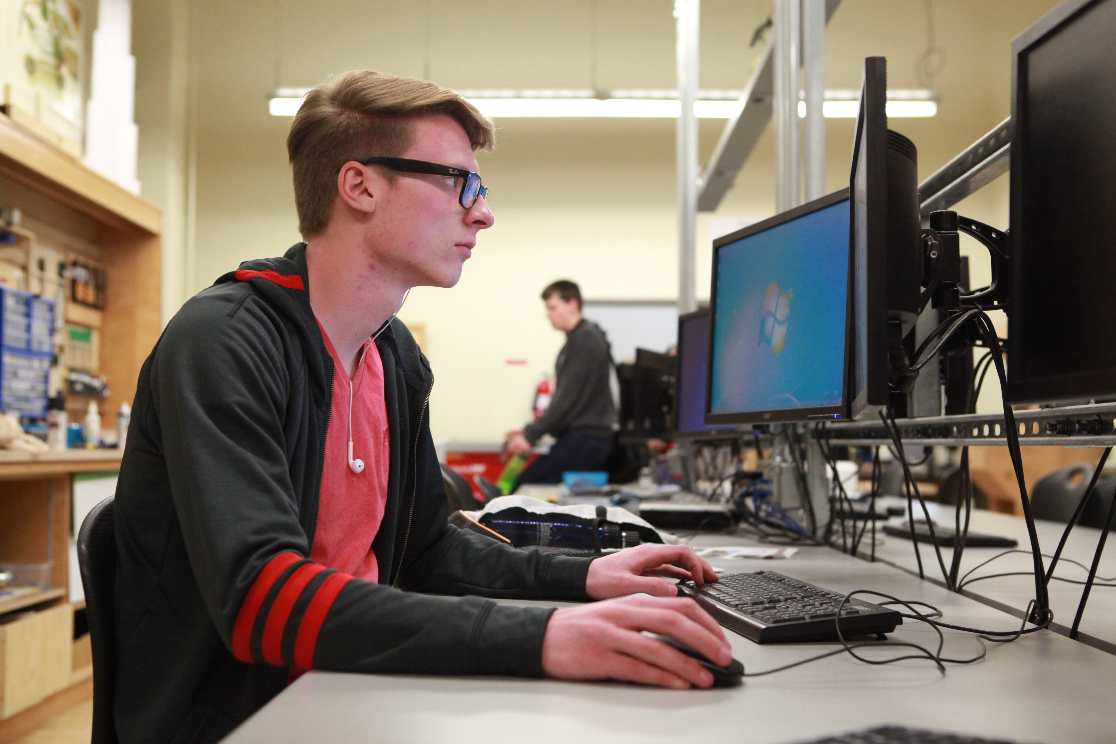
Design, Engineering, and Innovation DEI
Students have an opportunity at RTHS to select courses that enhance their knowledge and understanding of engineering and other Science, Technology, Engineering & Math (STEM) fields. The following courses will provide foundational knowledge and skills for students who are passionate about innovation and engineering.

Computing Science
Computing Science helps students develop strong foundational skills in computer coding. Computing Science 30 can be used for entrance into post-secondary institutions as a replacement for any of the three traditional science courses (Biology, Physics and/or Chemistry). Students must complete all three levels of computer science to use it for post-secondary entrance.

Computing Science 10
Students are introduced to a variety of computing topics, including the basics of how computers work, the relationship between hardware and software, the history of Computer Science, and how to build programs. Students will learn how to build their own website using JavaScript, HTML, and CSS. The majority of concepts will be introduced by having students create their own games. Prerequisite: None

Computing Science 20
Students develop skills gained in the 10-level course, and continue to look at how computers have influenced life and society. Students will be introduced to the Python language, while exploring more advanced topics of file access, working with graphics libraries, and a variety of data types. We will begin to study object-oriented programming. Prerequisite: Computing Science 10

Computing Science 30
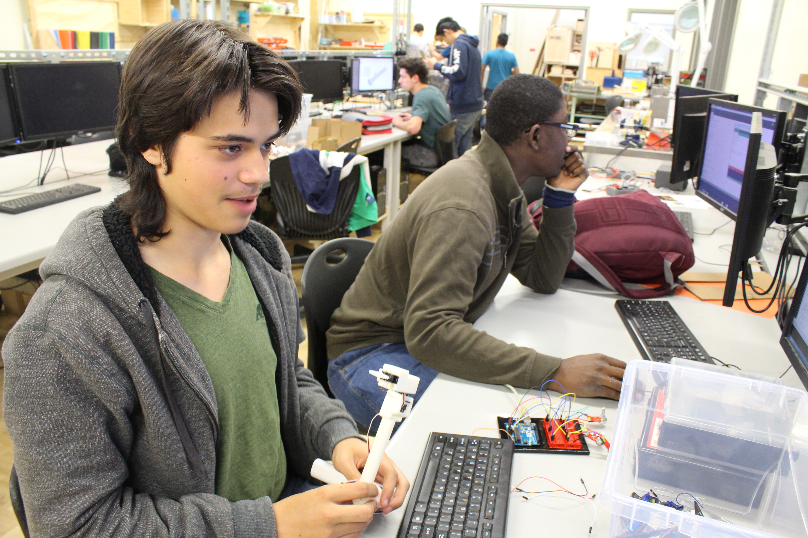
Students build on their previous skill and knowledge by focusing on the object-oriented approach to programming. Students continue in the Python programming language to explore the object-oriented approach to programming. Other topics include dynamic data structures, recursion, and searching and sorting methods. Server-side scripting and databases may also be introduced. Prerequisite: Computing Science 20

Computer Science 30 AP
In Advanced Placement Computer Science, students will learn about an array of structures and procedural programming techniques and their application through enriched programming projects. Students will learn how to create and process external data files as well as how to develop using an industry standard language, Java. In their second year, students will learn about Object Oriented Programming and inheritance to allow them to develop more complex projects in a well-organized manner. They will also learn fundamental iterative and recursive computer science algorithms, as well as, how to compare the performance of different algorithms using big O notation. Finally, all AP students will demonstrate their mastery through an individual project at the end of each semester. Prerequisite: Computing Science 10 with teacher recommendation

Robotics
Electro-Technologies Intro/Inter/Adv
Students will explore an array of electronic and robotic functions, applications, and principles. Students may design, build, and program robots to solve real-world problems. This is a great course for students to apply knowledge and critical thinking, while building their knowledge and capacity to work with electro-technologies.
Prerequisite: Robotics Intro or Inter

Design Studies
Design Studies Intro/Inter/Adv
Students will learn to design, engineer, and prototype innovative projects using a variety of programs, tools and technology. Students will explore 3D printing, and laser cutting. Prerequisite: Design Studies Intro or Inter

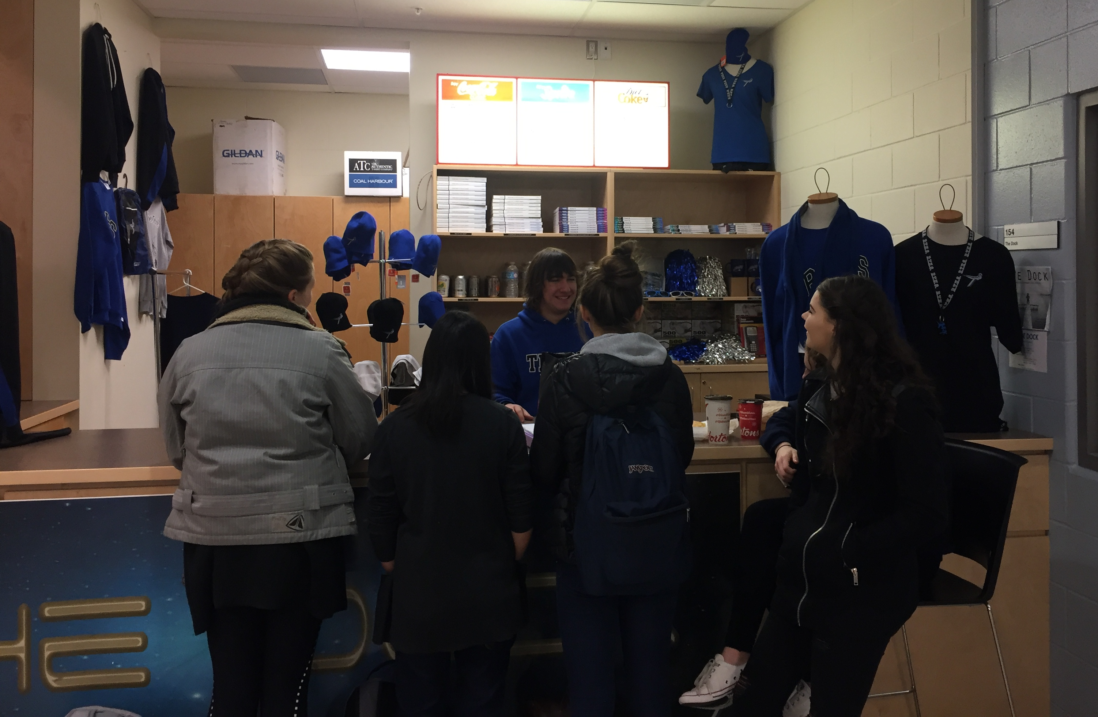
Business Administration, Finance and Information Technology (BIT)

Business Studies 10/20/30
Students will explore market basics, customer service, advertising, retail management and entrepreneurial skills, as well as software commonly used in a business setting. Students will use the skills and theories they learn to manage operation of the school store. Prerequisite: None

Health, Recreation & Human Services (HRH)

Foods Culinary Arts
Foods Culinary Arts Intro
Students will learn food production, food preparation, and meal planning. They will explore nutrition, healthy food choices, food costs, and safe food handling techniques. Students in this class will prepare food for the school cafeteria and catering. Each course contains theory and practical components. Students will complete a provincial food safety certification at this level that is required to proceed to the next level. Prerequisite: None

Foods Culinary Arts Inter/Adv
Students will continue to develop the skills needed to work in a commercial kitchen, while building their kitchen leadership skills. Safe and sanitary food handling practices based on industry standards will continue to be emphasized, and students will have an opportunity to complete courses necessary to challenge the first year Alberta Apprenticeship Cook Trade exam. Each course contains theory and practical components. Prerequisite: Foods Culinary Arts Intro or Inter

Legal Studies
Legal Studies Intro/Inter/Adv
Students will explore public, private, relationship and employment law through debate, discussion, mock trials and projects. Students will analyze real-world legal cases and examine the criminal justice system, including the criminal process and the roles and responsibilities of the participants. Prerequisite: None

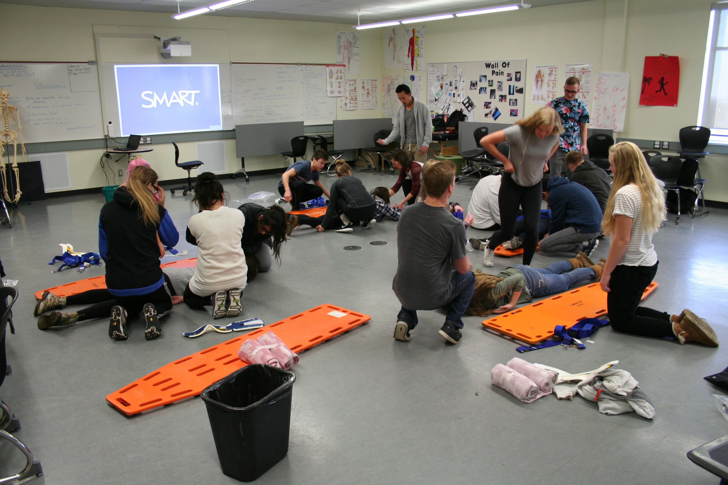
Sports Medicine
Sports Medicine Intro
Students are introduced to anatomy (bones, muscles and joints) and their relation to athletic injuries. Students will become CPR & AED certified by the Canadian Red Cross. The practical component of the course will involve an introduction to athletic taping and wrapping. Students will be required to complete 15 observational hours of athletics, outside of regular school hours. Prerequisite: None

Sports Medicine Inter
Students will further their study of human physiology, athlete health and performance, and introduction to injury rehabilitation. Recognition and treatment of injuries is the focus, by using student’s background in anatomy, and teaching of more advanced taping and wrapping skills. Students will be required to complete a minimum of 25 hours as trainers, and students must be prepared to dedicate a significant amount of time before and after school within the training environment. Prerequisite: Sports Medicine Intro
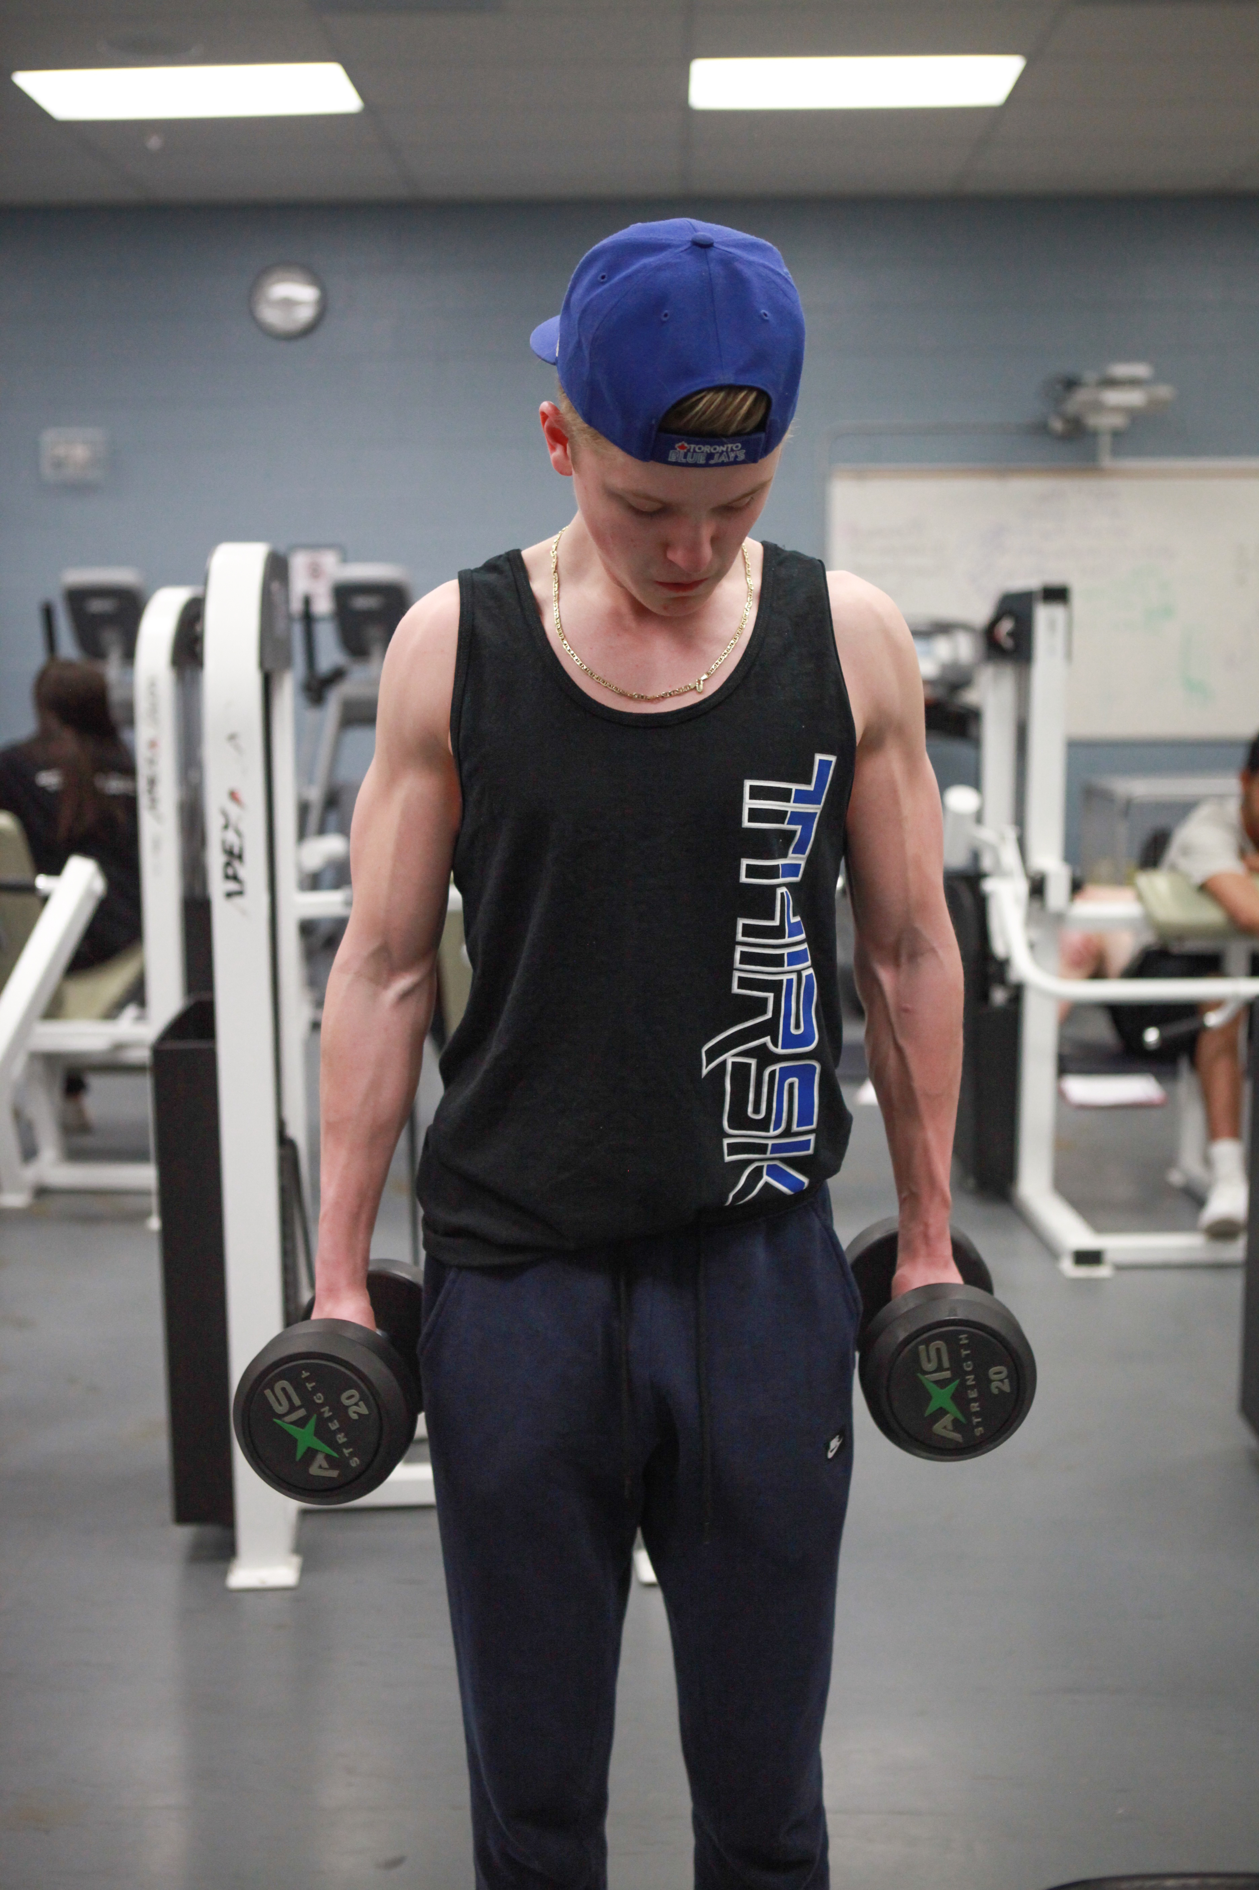

Sports Medicine Adv
Students will advance their study of anatomy and physiology, and examine Kinesiology, Physiotherapy and other related medical fields. Students will explore a variety of post-secondary opportunities and advanced rehabilitative methods available within the city. Some students will have the opportunity to work with Robert Thirsk students in a fitness and rehabilitation setting. Prerequisite: Sports Medicine Inter

Sports Performance
Sports Performance Intro/Inter/Adv
Students will focus on the development of an individual’s fitness as it relates to improving performance in sport. Topics of study include: aerobic training, strength training, flexibility training, agility training, power training, speed training, nutrition, hydration and goal setting. Prerequisite: Sports Performance Intro or Inter
NOTE | All levels of Sports Performance are extremely rigorous and physically demanding courses and should only be requested by students desiring high performance levels of physical fitness.

Leadership
Leadership Intro/Inter/Adv
Students will enhance their leadership skills and demonstrate the application of these skill sets through modeling and mentorship. Students will demonstrate commitment, responsibility, accountability and work ethic as they identify and implement projects that meet school and community needs. Prerequisite: Leadership Intro or Inter

Media, Design & Communication Arts (MDC)

Graphic Design
Graphic Design 10
Students will explore the tools and technology used for 2D graphic design applications, and develop skills in areas of photography, photo editing and vector graphic design Students will be introduced to the basics of DSLR photography, as well as industry standard graphics programs like Adobe Illustrator, Photoshop, and InDesign. Prerequisite: None
Graphic Design 20/30
Students will continue to develop the knowledge and skills they need to work with real clients, create EPK’s (Electronic Press Kits), promotional campaigns, posters, flyers, and web presence graphics. Students will develop more advance proficiency in programs such as Photoshop, Illustrator, Photography, as well as, photography and camera literacy. Prerequisite: Graphic Design 10 or 20

Natural Resources (NAT)
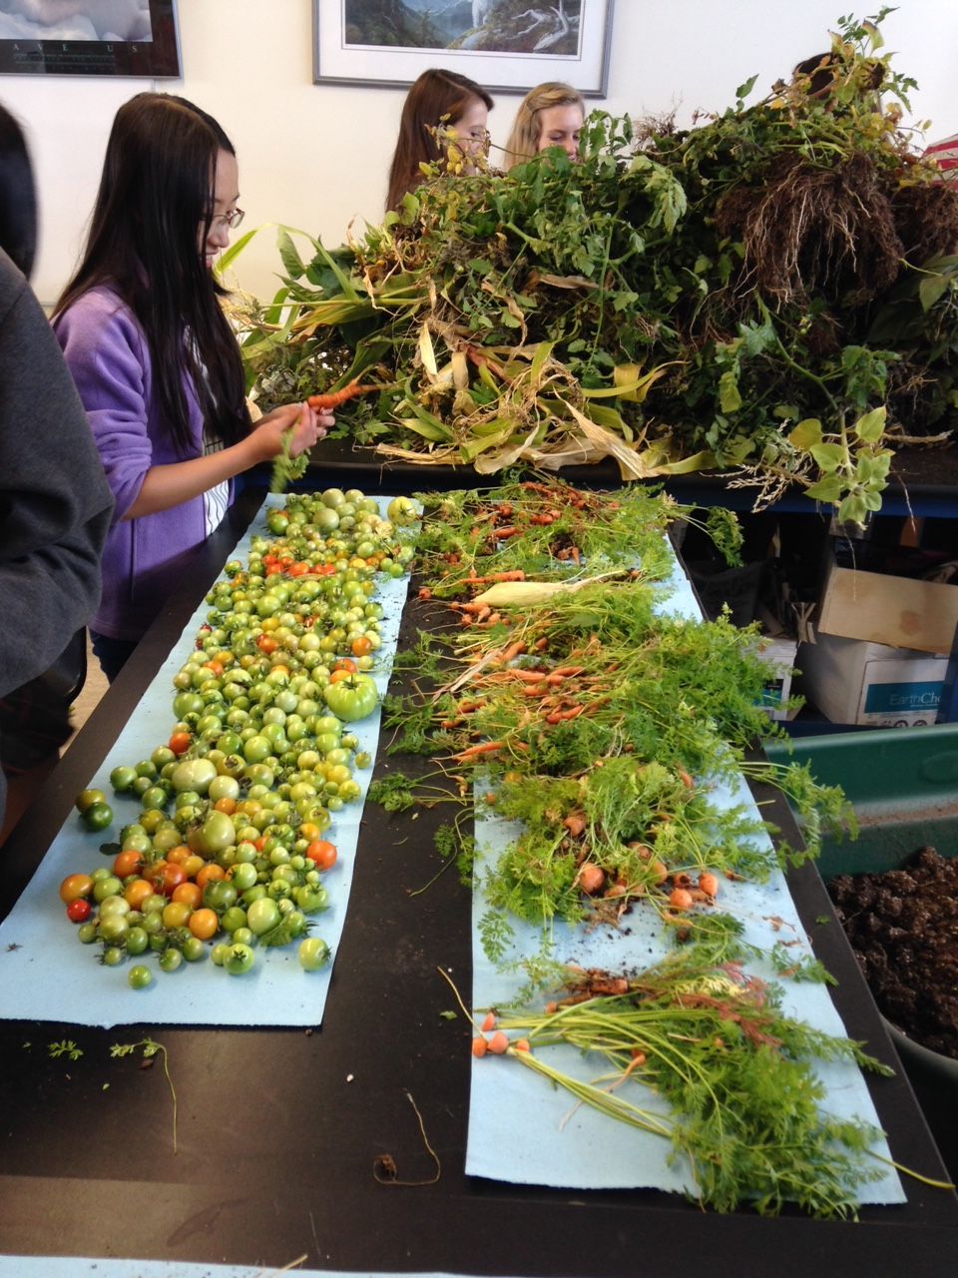
Natural Resources Intro/Inter/Adv
Students will examine the management and conservation of the environment at the local, provincial and national level. Students will explore the principles of stewardship in relation to the sustainable development of our environments. Greenhouse management, plant growth, and plant production will also be a significant focus. Prerequisite: None

Environmental and Outdoor Education Intro/Inter/Adv (Formerly Outdoor Pursuits)
Environmental and Outdoor Education is a 5 – 6 credit CTS course designed for students interested in exploring outdoor activities. Students will gain practical wilderness experience and environmental awareness along with an opportunity to participate in both day and over-night excursions. Students will receive certification in Wilderness First Aid. Prerequisite: None

Trades, Manufacturing & Transportation (TMT)
Construction Technology
Construction Intro
Students will develop processes and methods to complete practical hands-on projects. Students will learn to use a variety of hand and power tools safely. Construction intro will expose students be basic construction skills from choosing wood or composite materials, creating shop drawings, and tool use and care. Prerequisite: None

Construction Multi-level
Students will develop their practical skills by completing projects that are more complex, while emphasizing safety. Construction Technology 30 students will develop awareness and skills more appropriate for further pursuits in a technical post-secondary institution. Skills developed at these levels may include joinery skills, web and face framing and/or door and drawer cabinet making. Students may also learn how to develop a product for mass production. Prerequisite: Construction 10 or 20

Work Experience, RAP and Green Certificate
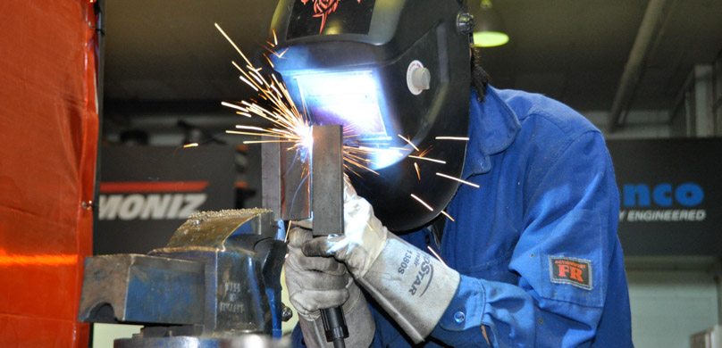
Note | Additional information is available from the Off Campus Education Coordinator. All of the above require special programming, planning and timetabling.

Work Experience 15/25/35
Work experience allows students to gain practical knowledge, enhance their skills, and form attitudes that will assist them in their transitions from school to the world of work. Existing part-time jobs may be eligible as a work experience placement provided the student can demonstrate that new learning is occurring. Prerequisite: HCS 3000

Registered Apprenticeship Program (RAP)
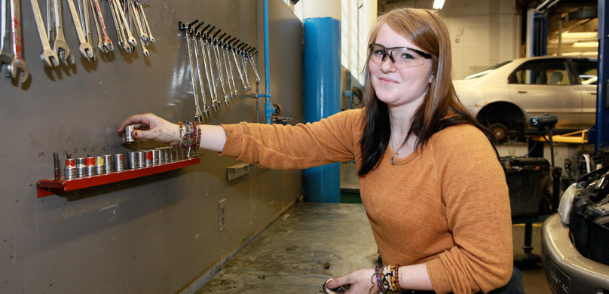
RAP is an excellent opportunity for students 15 years of age or older who know they want to enter a trade. Successful students can earn up to 40 RAP credits toward their high school graduation, as well as the hours needed for a first year apprenticeship. Prerequisite: HCS 3000

Green Certificate Program
The green Certificate program is an apprenticeship-style training program serving the agricultural industry. There are multiple areas of specialization, please discuss with the Success Centre if you are interested. Prerequisite: AGR 3000

Advanced Placement (AP)
Advanced Placement (AP) is one high school route for university preparation, providing enriched and challenging academic courses that parallel and expand on the material covered in Alberta Education curricula. These courses are designed to help develop good academic habits, analytical reasoning skills and disciplined study. AP provides the flexibility to take one or more courses depending on your interests. Successful completion of AP examinations can lead to obtaining credit for some first year university courses. In addition to the AP exams, you are required to write the Alberta Diploma Examinations in January or June. Students must purchase any required AP materials and pay a fee to write each AP exam in May. For more information on AP courses and university credits visit: https://www.collegeboard.org/

STEM AP Courses
Math 30-1/31 AP
This full-year course covers the Alberta Program of Studies for Mathematics 30-1, Mathematics 31 and the Calculus-AB AP curriculum. The Calculus-AB AP curriculum is designed to explore the concepts, methods and applications of differential and integral calculus. Students will work to understand the theoretical basis and solve problems by applying knowledge and skills. Prerequisite: Math 20-1 and teacher recommendation.

Computer Science 30 AP
In Computer Science AP, students will learn a variety of programming techniques, and how to apply them effectively. Students will learn how to create and process external data files as well as use Java, an industry standard language. As the program progresses, students learn about Object Oriented Programming and inheritance. They will also learn fundamental iterative and recursive computer science algorithms as well as how to compare the performance of different algorithms using big O notation. Finally, all AP students will practice developing their own project to demonstrate their mastery at the end of each semester. Prerequisite: Computer science intro 20-1 teacher recommendation.

Biology 20/30/35AP
This full-year course covers the Alberta Program of Studies for Biology 20, Biology 30 and the content from the Biology AP curriculum. Specifically, the Biology AP curriculum encompasses four big ideas; Evolution, Energetics, Information Storage and Transmission, and Systems Interactions. There is a significant emphasis on lab skills, inquiry, and high learning in all content areas. Prerequisite: Science 10, Math 10C and teacher recommendation

Chemistry 30/35AP
This full-year course encompasses the Alberta Program of Studies for Chemistry 30 as well as the Chemistry AP curriculum. The Chemistry AP course framework includes two essential components; science practices and course content. The science practices describe what a student should be able to do while exploring course concepts. Specifically, the course content encompasses four big ideas; Scale, Proportion, and Quantity, Structure and Properties, Transformations, and Energy. Prerequisite: Science 10, Math 10C and teacher recommendation

Physics 30/35AP
This full-year course covers the Alberta Program of Studies for Physics 30 and the content from the Physics 1 AP curriculum. Specifically, students taking this course will cover topics in Mechanics, Electromagnetism, and Atomic & Nuclear Physics. Students who already have Physics 20 credits may enroll in this course and begin at the end of Term 1. Prerequisite: Science 10, Math 10C and teacher recommendation

Humanities & the Arts AP Classes
Art 30AP
This is a semester based course that is designed to enhance the Art 30 curriculum and allow students to investigate the materials, processes, ideas and skills that artists and designers utilize daily in their work. The AP Art and Design program includes three different courses and portfolio exams, students can choose to take one or more in discussion with their Art teacher. A portfolio of work will need to be curated and submitted to the AP board to produce an AP score for the program. Prerequisite: Art 20 with teacher recommendation

English 20/30/35AP
This enriched program covers the Alberta Program of Studies for English 20-1 and 30-1, as well as additional outcomes from the AP English Literature & Composition curriculum. Students will learn to understand and evaluate works of fiction, poetry and drama from various periods and cultures. There is both an essay/written component and comprehension component to the AP exam. Prerequisite: English Language Arts 10-1 with teacher recommendation.

Social Studies 30-1/35 AP
This enriched program covers the Alberta Program of Studies for Social Studies 30-1, as well as additional outcomes from the AP European History curriculum. Students will study the cultural, economic, political and social developments that have shaped Europe from 1450 to the present. Additionally, students will analyze texts, visual sources and other historical evidence, and write essays expressing historical arguments. Prerequisite: Social Studies 10-1 with teacher recommendation.

Spanish L&C 30AP
Spanish Language and Culture AP is equivalent to an intermediate level post-secondary course in Spanish. Students acquire understanding of the Spanish language through speaking, listening, writing and reading. The Spanish Language and Culture AP course strives not to overemphasize grammatical accuracy at the expense of communication. Students will explore concepts such as family and community, personal and public identities, contemporary life and global challenges. This course is taught almost exclusively in Spanish. Students who wish to take this course must have completed and excelled at the Spanish Language and Culture 30, or completed Spanish Language Arts 10. Prerequisite: Spanish 20 or Spanish Language Arts 10 with teacher recommendation

Unique Pathways & Dual-Credit Courses
The CBE collaborates with post-secondary institutions, industry partners and community organizations to offer a wide-range of unique opportunities for students. These range from practical, hands-on learning experiences in exploratory programs to Dual Credit courses and programs that allow students to participate in post-secondary learning with the support of a supervising CBE teacher. These programs allow students to complete high school their own way, and set students up for future success by easing the transition to post-secondary learning and/or the workplace.
Unique Opportunities are organized into three main categories:
- Exploratory: earn high school credit and industry credentials while exploring career possibilities. Learn from industry mentors in an authentic setting.
- Dual Credit: earn high school and post-secondary credits at the same time. Some programs may also include industry credentialing.
- Internships: participate in intensive experiences in the world of work and earn high school credits.

Important | To earn Work Experience credits as part of an Exploratory or Internship program above, a workplace safety course (HCS 3000) must be completed at your high school first.



RTHS COURSE LISTINGS
Grade 10 | Grade 11 | Grade 12
English 10-1 (5)  English 10-2 (5)  English 10-4 (5) | English 20-1 (5)  English 20-2 (5)  English 20-1/30-1/35 Cohort AP (13)  English 20-4 (5) | English 30-1 (5)  English 30-2 (5)  English 20-1/30-1/35 Cohort AP(13)  English 30-4 (5)
Social Studies 10-1 (5)  Social Studies 10-2 (5)  Social Studies 10-4 (5) | Social Studies 20-1 (5)  Social Studies 20-2 (5)  Social Studies 20-4 (5)  Social Studies 20-1/30-1/35 Cohort AP (13) | Social Studies 30-1 (5)  Social Studies 30-2 (5)  Social Studies 20-1/30-1/35 Cohort AP (13)
Mathematics 15 (5)  Mathematics 10C (5)  Mathematics 10-3 (5)  Mathematics 10-4 (5) | Mathematics 20-1 (5)  Mathematics 20-2 (5)  Mathematics 20-3 (5)  Mathematics 20-4 (5)  Math 20-1 Cohort AP (5) | Mathematics 30-1 (5)  Mathematics 30-2 (5)  Mathematics 30-3 (5)  Mathematics 30-1/31 Cohort AP (10)  Mathematics 31 (5)
Science 10 (5)  Science 14 (5)  Science 10-4 (5) | Biology 20 (5)  Biology 20/30/35 Cohort AP (13)  Chemistry 20 (5)  Chemistry 20/30/35 Cohort AP (13)  Physics 20 (5)  Physics 20/30/35 Cohort AP (13)  Science 20 (5)  Science 24 (5)  Science 20-4 (5) | Biology 30 (5)  Biology 20/30/35 Cohort AP (13)  Chemistry 30 (5)  Chemistry 20/30/35 Cohort AP (13)  Physics 30 (5)  Physics 20/30/35 Cohort AP (13)  Physics 30/35AP (8)  Science 30 (5)
*Number in brackets indicate credit number potential per course
COMPLEMENTARY COURSES
COMPLEMENTARY  Creative Writing & Publishing (5)  Journalism15 (5)  Math 15 (5)  Physical Education 10 (5)  Yoga 15 (5)  Positive Psychology | Creative Writing & Publishing 25 (5)  Forensic Science 25/35 (5)  Journalism 25 (5)  Physical Education 20 (5)  Psychology 20/30 (3-6)  Yoga 25 (5) | Creative Writing & Publishing 35 (5)  Forensic Science 25/35 (5)  Journalism 35 (5)  Physical Education 30 (5)  Psychology 20/30 (3-6)  Yoga 35 (5)
GLOBAL STUDIES  Aboriginal Studies 10 (5)  ELL Multi-level  French 10-3Y (5)  French 20-3Y (5) (Jr High French or Immersion)  Spanish L&C 10-3Y (5)  Spanish Language Arts 10 (5) (Jr. High Spanish or Bilingual) | Aboriginal Studies 20 (5)  ELL Multi-level  French 20-3Y (5)  Spanish L &C 20-3Y (5)  Spanish L&C 30 Cohort AP (5-10) | Aboriginal Studies 30 (5)  ELL Multi-level  French 30-3Y (5)  Spanish L&C 30-3Y (5)  Spanish L&C 30 Cohort AP (5-10)
FINE ARTS  Art 10 (5)  Dance 15 (5)  Drama 10 (5)  General Music 10 (5)  Instrumental Music 10 (5)  Musical Theatre Multi-level (5)  Technical Theatre 15 (5)  No request required:  Band 15 – Corequisite of Inst. Music 10 | Art 20 (5)  Dance 25 (5)  Drama 20 (5)  General Music 20 (5)  Instrumental Music 20 (5)  Musical Theatre Multi-level (5)  Technical Theatre 25 (5)  No request required:  Band 25 – Corequisite of Inst. Music 20 | Art 30 (5)  Art 30 Cohort AP (5-10)  Dance 35 (5)  Drama 30 (5)  General Music 30 (5)  Instrumental Music 30 (5)  Musical Theatre Multi-level (5)  Technical Theatre 35 (5)  No request required:  Band 35 – Corequisite of Inst. Music 30
CAREER & TECHNOLOGY STUDIES (CTS)  Business Studies 10  Computing Science 10  Construction Intro  Design Studies Intro  Foods Culinary Arts Intro  Graphic Design Intro  Leadership Intro  Legal Studies Intro  Natural Resources Intro  Environmental & Outdoor Ed.  Robotics Intro  Sports Medicine Intro  Sports Performance Intro | Business Studies 20  Computing Science 20  Computer Science 20/30 Cohort AP  Construction Inter  Design Studies Inter  Foods Culinary Arts Inter  Graphic Design inter  Leadership Inter  Legal Studies Inter  Natural Resources Inter  Outdoor Pursuits multi-level  Robotics Inter  Sports Medicine Inter  Sports Performance Inter | Business Studies 30  Computing Science 30  Computer Science 20/30 Cohort AP  Construction Adv  Design Studies Adv  Foods Culinary Arts Adv  Graphic Design Adv  Leadership Adv  Legal Studies Adv  Natural Resources Adv  Outdoor Pursuits multi-level  Robotics Adv  Sports Medicine Adv  Sports Performance Adv

